**Caja blanca: Agenda**

1. **addEntry**

* **Función**

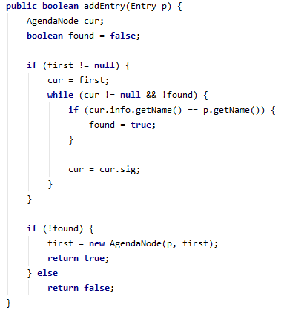

* **Grafo** (Realizado con el método explicado en **clase práctica**)

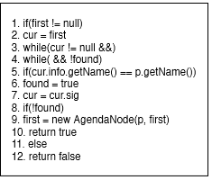

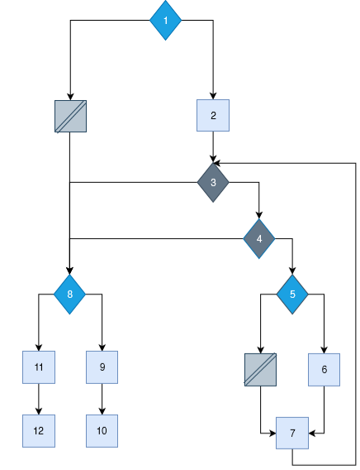

**Complejidad ciclomática**:

Nº de rombos + 1 = 5 + 1 = 6

* **Caminos independientes**
* 1-8-9-10
* 1-8-11-12
* 1-2-3-4-8-9-10
* 1-2-3-4-8-11-12
* 1-2-3-4-5-6-7-3-8-9-10
* 1-2-3-4-5-6-7-3-8-11-12
* **Casos de prueba**

|  |  |  |  |  |  |  |  |  |
| --- | --- | --- | --- | --- | --- | --- | --- | --- |
| **Prueba** | **first** | **cur** | **found** | **curName** | **pName** | **found** | **return** | **factible** |
| 1 | null | any | any | any | any | false | true | yes |
| 2 | null | any | any | any | any | true | false | yes |
| 3 | !null | null | false | any | any | false | true | yes |
| 4 | !null | !null | true | any | any | true | false | no |
| 5 | !null | !null | false | =pname | =curName | true | false | yes |
| 6 | !null | !null | false | !=pname | !=curName | false | true | yes |

* **JUnit**
* **Prueba 1**

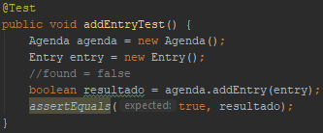

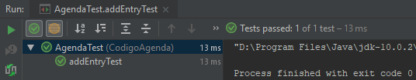

* **Prueba 2**

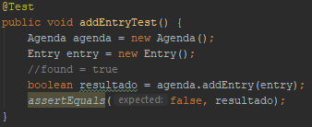

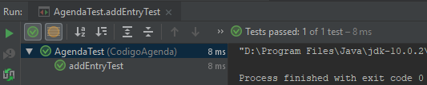

* **Prueba 3**

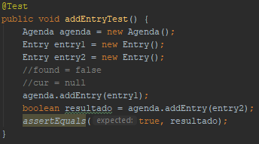

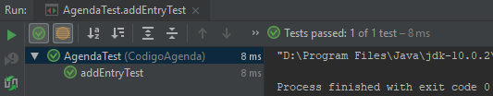

* **Prueba 5**

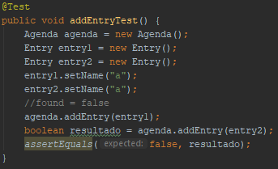

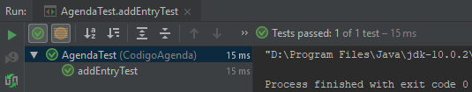

* **Prueba 6**

